Brady Middle/High School ACE Fact Sheet
Year 1

Increase Attendance:
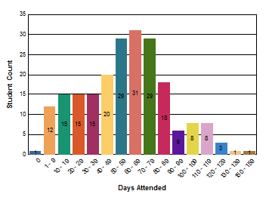
- 146 Regular Students (45 days or more) attended the ACE Program 62 students attended for less than 45 days
- 57 Parents attended ACE activities (50 required)

Increase Academic Improvement:
- Reading: 76% of ACE students increased or did not need to increase their grades from fall to spring
- Math: 62% of ACE students increased or did not need to increase their grades from fall to spring
STAAR Results for ACE Students | % Passing for All Students in Campus where center is located | # of ACE Students STAAR Tested | # ACE Students Passing STAAR | % ACE Students Passed
Reading | 81.15% | 183 | 145 | 79.23%
Mathematics | 93.03% | 183 | 167 | 91.26%

Reduce Student Behavior:

Out of Regular Classroom | 2019
Decreased Behavior *(Criminal referrals) | 2
Decreased Behavior *  (Non-criminal referrals) | 6

Increase Promotion Rates:

 | 2019
# ACE Students Retained | 4

Maintain Graduation Rates:
 | 2019
% of ACE students graduating | 100%

